# AWS Lambda with C#

1. You need to have AWS extensions installed in Visual Studio 2017

Go to Tools>

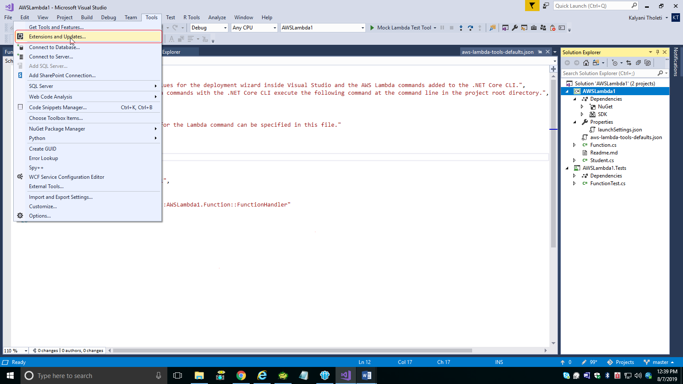

AWS toolkit for Visual Studio 2017 and 2019 need to be installed.

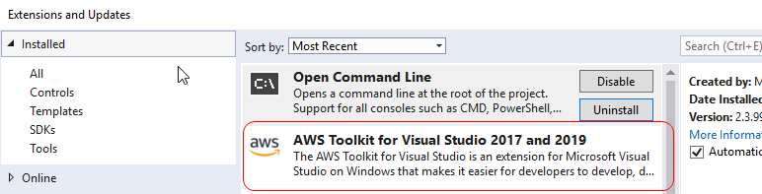

1. Create New project. Select AWS Lambda

